Modeling and Control of AUV Depth and Pitch Using PID and LQR Techniques

Author: Safa Bazrafshan

Date: June 2025

Email: safa.bazrafshan@gmail.com

GitHub: github.com/safa-bazrafshan

LinkedIn: linkedin.com/in/safa-bazrafshan-04100a29a

ORCID: https://orcid.org/0009-0004-4029-9550

**1. Introduction**

This project presents the modeling and control of an Autonomous Underwater Vehicle (AUV) with a focus on depth and pitch control. The goal is to simulate and compare classical PID control and modern state-space LQR control methods under both nominal and disturbed underwater conditions.

**2. Objectives**

Develop a simplified linear state-space model of an AUV

Design and simulate PID and LQR controllers

Test system response with and without environmental disturbances (e.g., underwater currents)

Evaluate the performance and robustness of the control strategies

**3. System Modeling**

A 2D AUV motion model is implemented in MATLAB based on linearized state-space dynamics. The model includes the following states:

Heave (vertical displacement)

Pitch angle

Vertical velocity

Pitch rate

**4. Control Design**

**4.1 PID Control**

Implemented a PID controller for depth

PD controller for pitch stabilization

Suitable for basic reference tracking

**4.2 LQR Control**

Full-state feedback design using MATLAB's lqr() function

Cost matrices Q and R tuned for optimal tracking and stability

Shows better performance and robustness compared to PID

**5. Disturbance Analysis**

Simulated external sinusoidal water current as a disturbance input

LQR controller showed minimal deviation and fast recovery

System remained stable under environmental uncertainty

**6. Results**

All simulations were carried out in MATLAB and Simulink. The figures below show the response of depth and pitch to various controllers.

Fig 1–2: Depth response using PID and LQR

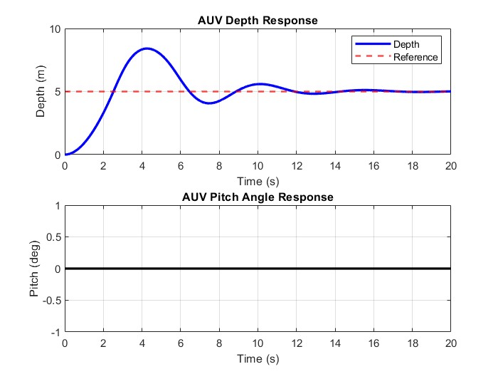

Fig 1: Depth and pitch response under PID control

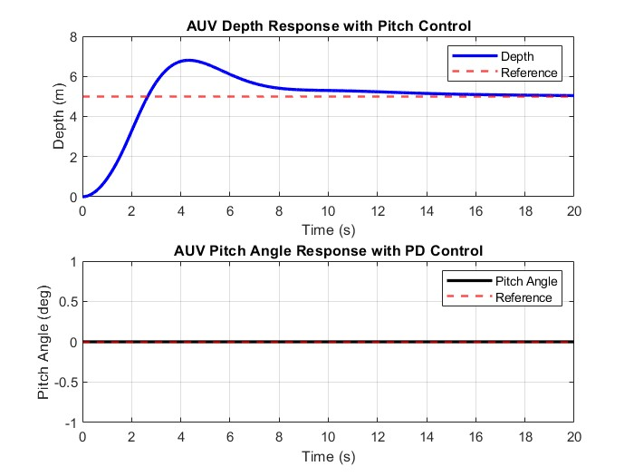

Fig 2: Depth and pitch response under LQR control (no disturbance)

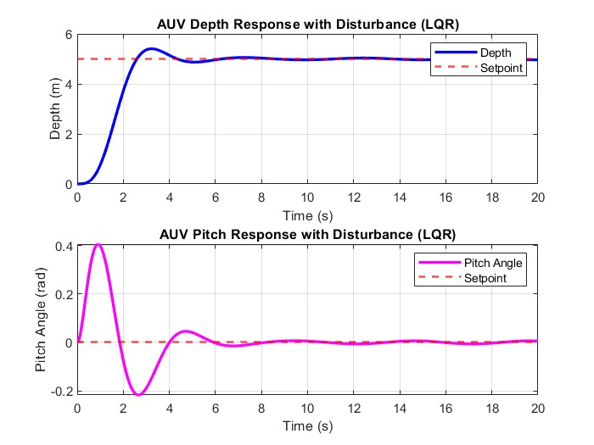

Fig 3: Depth and pitch response under LQR control with water current disturbance

**7. Conclusion**

The LQR controller offers superior stability and robustness for AUV motion control. This phase demonstrates a strong foundation for future work on adaptive, nonlinear, or MPC-based controllers for underwater robotics.

**8. Future Work**

Integrate LQI control for steady-state error elimination

Implement Model Predictive Control (MPC)

Add 3D modeling and actuation delays

Submit this project as a journal/conference paper

Note: This project is Phase 1 of a broader research and development effort in AUV control systems.